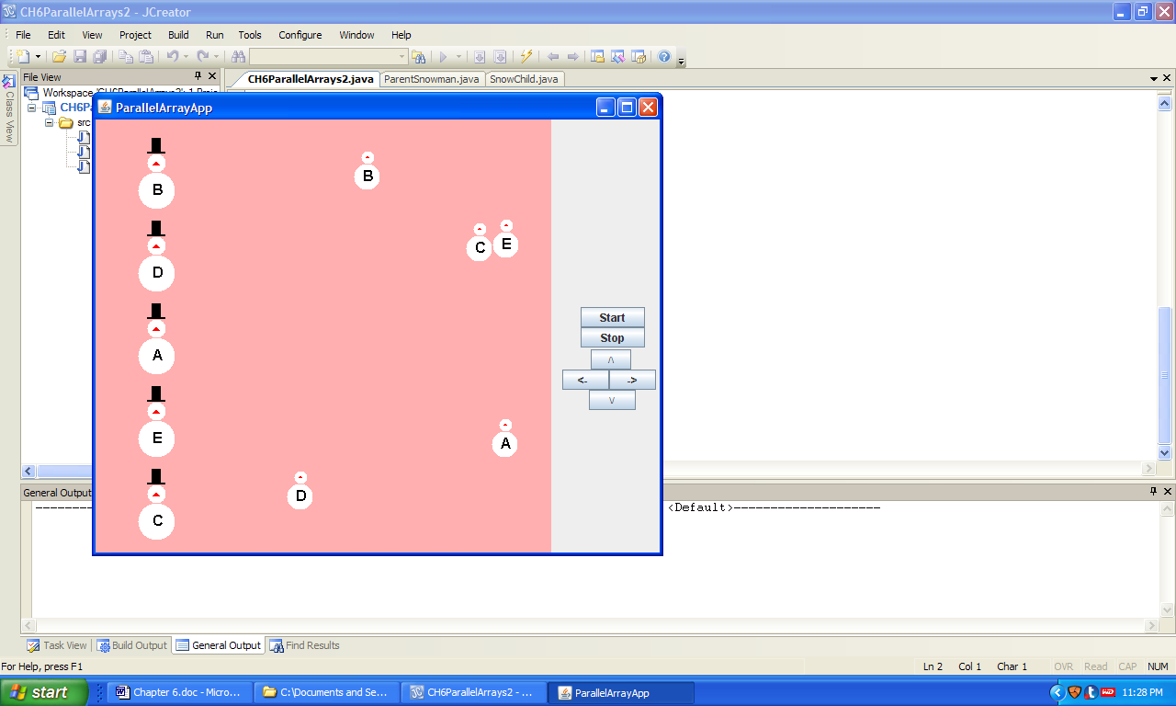 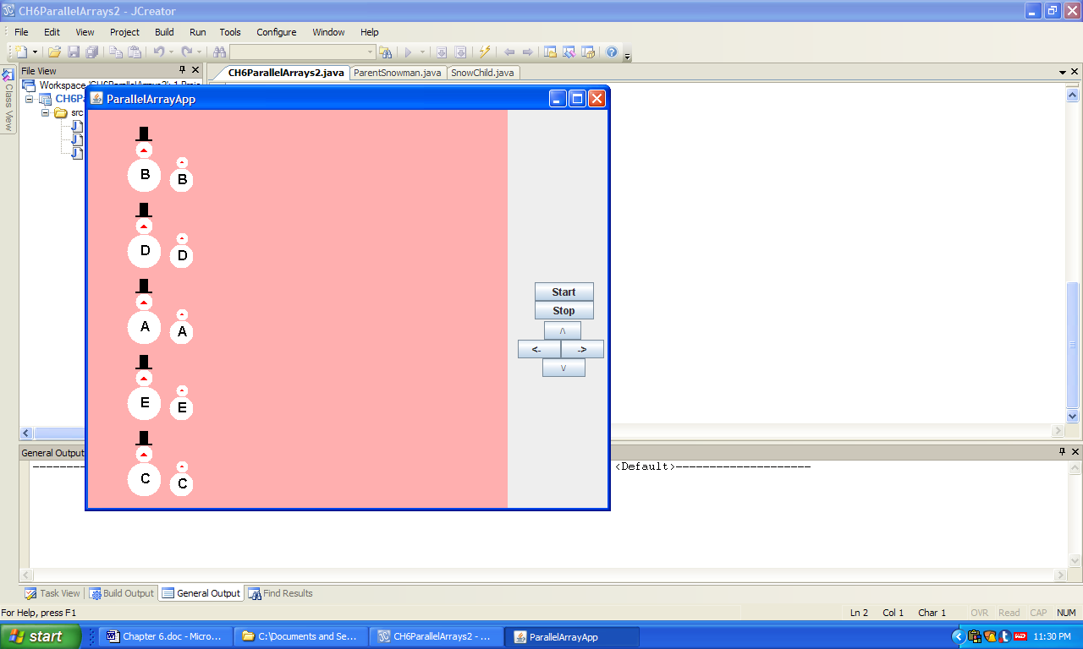

a) b)

**Figure 6.20 The graphical output of the application ParallelArrays.**